# Assignment 2

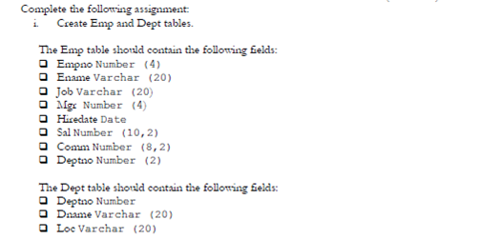

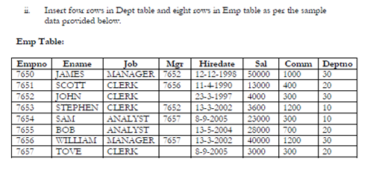

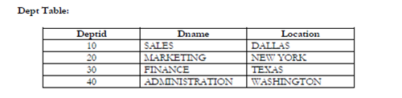

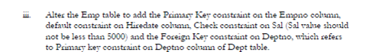

New Picture3

v. Write the following SQL queries based on above tables:-

1. Write a query in SQL to display all the information of the employees.

2. Write a query in SQL to find the salaries of all employees.

3. Write a query in SQL to display the unique designations for the employees

4. Write a query in SQL to list the ename and salary is increased by 15%.

5. Write a query in SQL to produce the output of employees name and job name as a format of "Employee & Job".

6. Write a query in SQL to produce the output of employees as follows.

Employee JAMES (manager).

7. Write a query in SQL to list the employees with Hire date in the format like February 22, 1991.

8. Write a query in SQL to count the no. of characters without considering the spaces for each name.

9. Write a query in SQL to list the empno, salary, and commission of all the employees.

10. Write a query in SQL to display the unique department with jobs.